Packet Tracer - Help and Navigation Tips

1. Topology

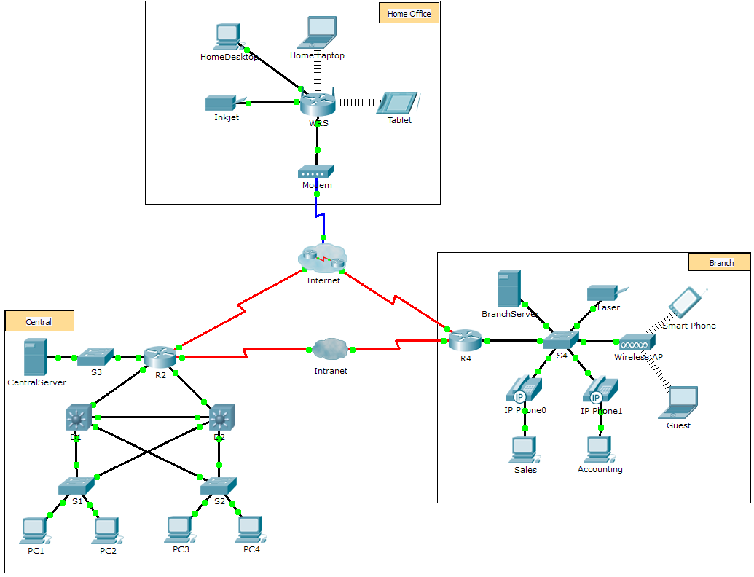

1. Objectives

Overview of the Packet Tracer Program

1. Background

Packet Tracer is a fun, take-home, flexible software program which will help you with your Cisco Certified Network Associate (CCNA) studies. Packet Tracer allows you to experiment with network behavior, build network models, and ask "what if" questions.

In this activity, you will explore a relatively complex network that highlights a few of Packet Tracer’s features. While doing so, you will learn how to access Help and the tutorials. You will learn how to switch between various modes and workspaces. You may need to adjust the window size of Packet Tracer to see the full network. If necessary, you can use the zoom in and out tools to adjust the size of the Packet Tracer window.

**Note**: It is not important that you understand everything you see and do in this activity. Feel free to explore the network on your own. If you wish to proceed more systematically, follow the steps below. Answer the questions to the best of your ability.

* 1. Access the Packet Tracer Help pages, tutorial videos, and online resources
     1. Access the Packet Tracer Help pages in two ways:
* Click the question mark icon in the top, right-hand corner of the menu toolbar.
* Click the Help menu, and then choose Contents.
  + 1. Access the Packet Tracer tutorial videos by clicking **Help** > **Tutorials**. These videos are a visual demonstration of the information found in the **Help** pages and various aspects of the Packet Tracer software program. Before proceeding with this activity, you should gain some familiarity with the Packet Tracer interface and Simulation mode.
       1. View the **Interface Overview** video in the **Getting Started** section of Tutorials.
       2. View the **Simulation Environment** video in the **Realtime** and **Simulation Modes** section of **Tutorials**.
    2. Find the “Configuring Devices Using the Desktop Tab” tutorial. Watch the first part of the tutorial and answer the following question: What information can you configure in the IP Configuration window?

____________________________________________________________________________________

____________________________________________________________________________________

* 1. Toggle between Realtime and Simulation modes.
     1. Find the word **Realtime** in the bottom right corner of the Packet Tracer interface. In Realtime mode, your network is always running like a real network, whether or not you are working on the network. Your configurations are performed in real time, and the network responds in near real time.
     2. Click the tab directly behind the **Realtime** tab to switch to **Simulation** mode. In Simulation mode, you can watch your network run at a slower pace, observing the paths that data takes, and inspecting the data packets in detail.
     3. In the Simulation Panel, click **Auto Capture / Play**. You should now see data packets, represented as envelopes of various colors, traveling between the devices.
     4. Click **Auto Capture / Play** again to pause the simulation.
     5. Click **Capture / Forward** to step through the simulation. Click the button a few more times to see the effect.
     6. In the network topology on the left, click one of the envelopes on an intermediary device and investigate what is inside. Over the course of your CCNA studies, you will learn the meaning of most everything inside these envelopes. For now, see if you can answer the following questions:
* Under the **OSI Model tab**, how many **In Layers** and **Out Layers** have information?

________________________________________________________________________________

* Under the **Inbound PDU Details** and **Outbound PDU Details** tabs, what are the headings of the main sections?

________________________________________________________________________________

* Click back and forth between the **Inbound PDU Details** and **Outbound PDU Details** tabs. Do you see information changing? If so, what?

________________________________________________________________________________

________________________________________________________________________________

* + 1. Click the toggle button above **Simulation** in the bottom right corner to return to **Realtime** mode.
  1. Toggle between Logical and Physical views.
     1. Find the word **Logical** in the top left corner of the Packet Tracer interface. You are currently in the Logical workspace where you will spend the majority of your time building, configuring, investigating, and troubleshooting networks.

**Note**: Although you can add a geographical map as the background image for the Logicalworkspace, it does not usually have any relationship to the actual physical location of devices.

* + 1. Click the tab below **Logical** to switch to the **Physical** workspace. The purpose of the Physical workspace is to give a physical dimension to your Logical network topology. It gives you a sense of scale and placement (how your network might look in a real environment).
    2. During your CCNA studies, you will use this workspace on occasion. For now, just know that it is available for you to use. To learn more about the Physical workspace, refer to the Help files and tutorial videos.
    3. Click the toggle button below **Physical** in the top right corner to return to the **Logical** workspace.